**Proof of Concept (PoC): Deploying Linkerd on MicroK8s in AWS EC2**

**Objective**

To deploy **Linkerd** as a service mesh on **MicroK8s** running on an Ubuntu-based **AWS EC2** instance and validate its functionality by running a sample application.

**Step 1: Launch an EC2 Instance with Ubuntu OS**

* Launch an AWS EC2 instance with **Ubuntu 22.04** or later.
* Ensure **security groups** allow required ports (e.g., **22 for SSH, 8084 for Linkerd Dashboard**).
* Connect to the instance using SSH:
* ssh -i your-key.pem ubuntu@your-ec2-public-ip

**Step 2: Install MicroK8s on Ubuntu**

Follow the official tutorial: [Install MicroK8s](https://ubuntu.com/tutorials/install-a-local-kubernetes-with-microk8s#2-deploying-microk8s)

**Install MicroK8s and Required Dependencies**

sudo snap install microk8s --classic

sudo snap install kubectl --classic

**Configure Kubernetes Permissions**

mkdir -p /home/ubuntu/.kube

sudo usermod -a -G microk8s ubuntu

sudo chown -R ubuntu ~/.kube

newgrp microk8s

microk8s config > ~/.kube/config

Verify MicroK8s is running:

microk8s status --wait-ready

**Step 3: Install and Configure Linkerd**

Follow the [Linkerd Official Guide](https://linkerd.io/2.17/getting-started/).

**Enable Linkerd in MicroK8s**

microk8s enable community

microk8s enable linkerd

**Check Linkerd Installation**

microk8s linkerd check

**Step 4: Deploy a Sample Application (Emojivoto)**

curl --proto '=https' --tlsv1.2 -sSfL https://run.linkerd.io/emojivoto.yml | kubectl apply -f -

**Inject Linkerd into the Emojivoto Deployment**

kubectl get -n emojivoto deploy -o yaml | microk8s linkerd inject - | kubectl apply -f -

**Check if Proxy is Injected**

microk8s linkerd -n emojivoto check --proxy

microk8s linkerd check

**Step 5: Expose Services via Port Forwarding**

**Expose Emojivoto Web Service**

kubectl -n emojivoto port-forward svc/web-svc 8080:80 --address 0.0.0.0  
  
  
http://44.204.206.140:8080/  
  
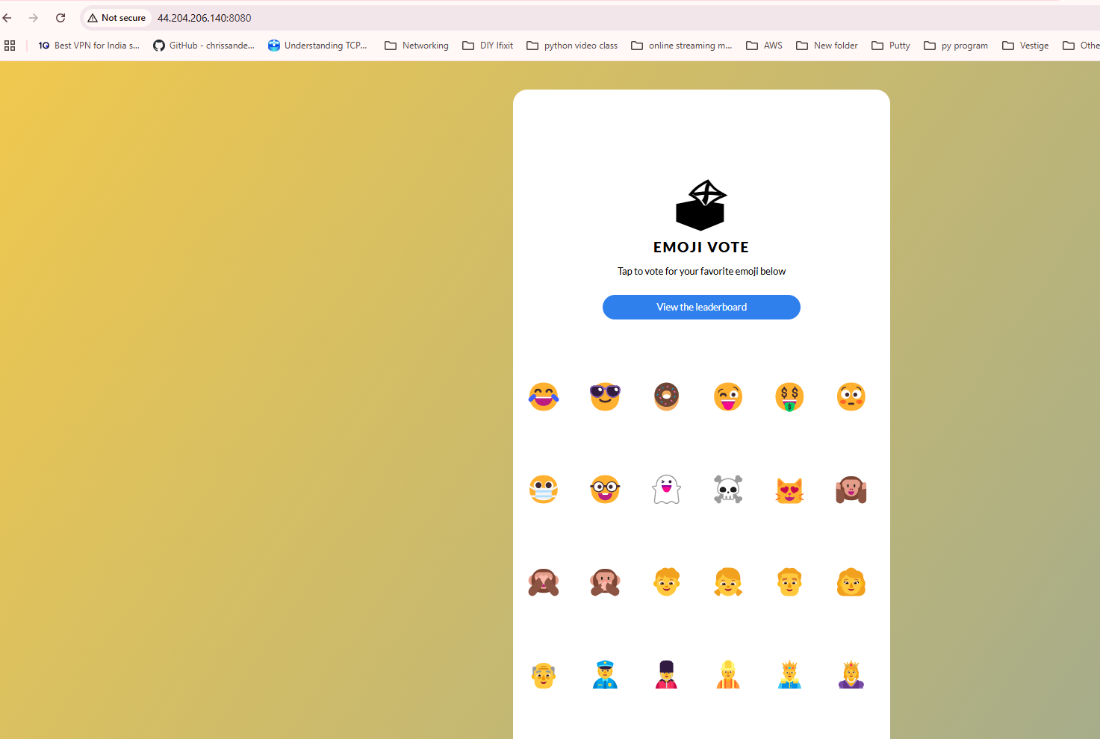  
  
Success  
  
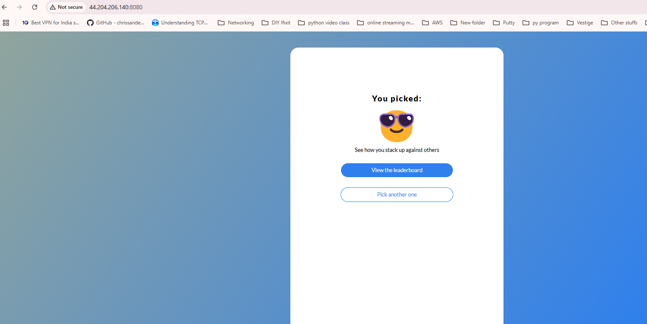  
  
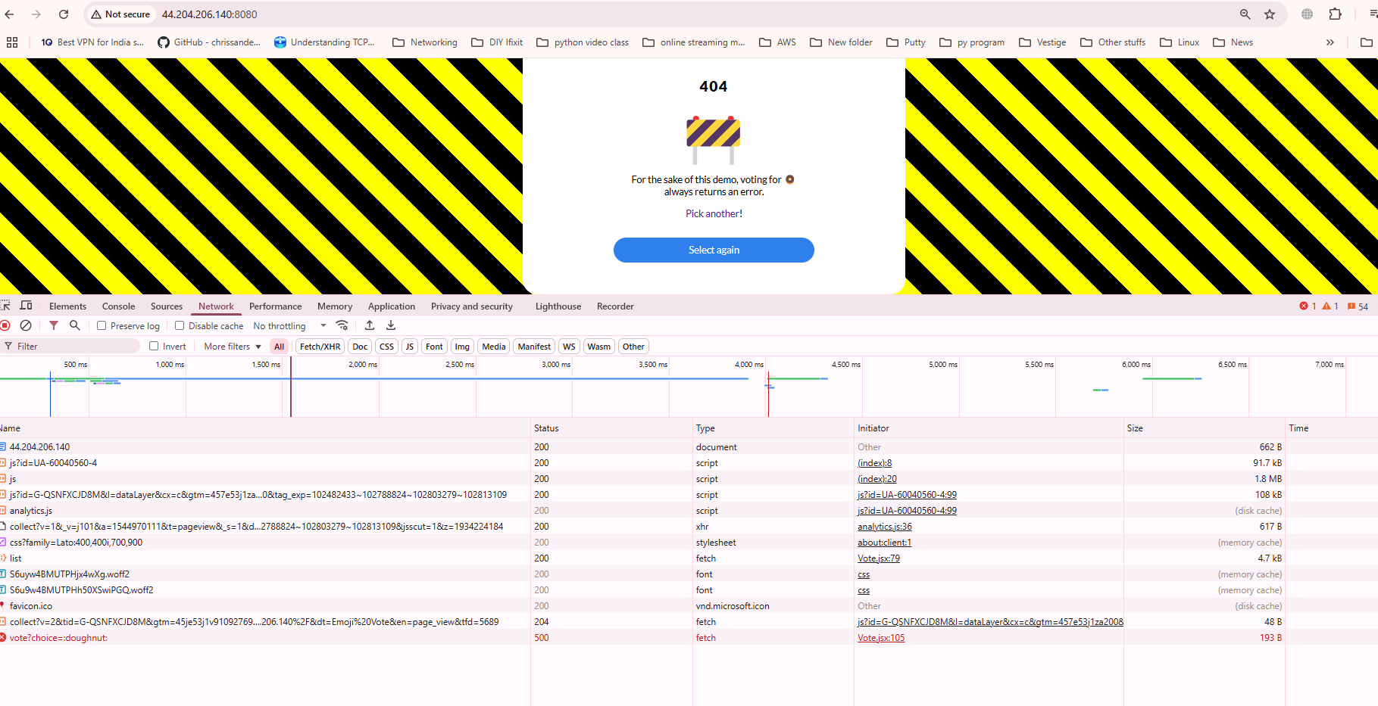  
  
  
Note : If you click around Emojivoto, you might notice that it’s a little broken! For example, if you try to vote for the **donut** emoji, you’ll get a 404 page.

**Modify Linkerd Dashboard Deployment for External Access**

Edit the deployment file:

kubectl edit deployment web -n linkerd-viz

Find and modify this line in the args section:

- -enforced-host=.*

Verify pods are running:

kubectl get po -n linkerd-viz

**Expose Linkerd Dashboard**

kubectl port-forward -n linkerd-viz svc/web 8084:8084 --address 0.0.0.0

Access Linkerd Dashboard via:

http://44.204.206.140:8084/

(Replace with your EC2 public IP)  
  
  
  
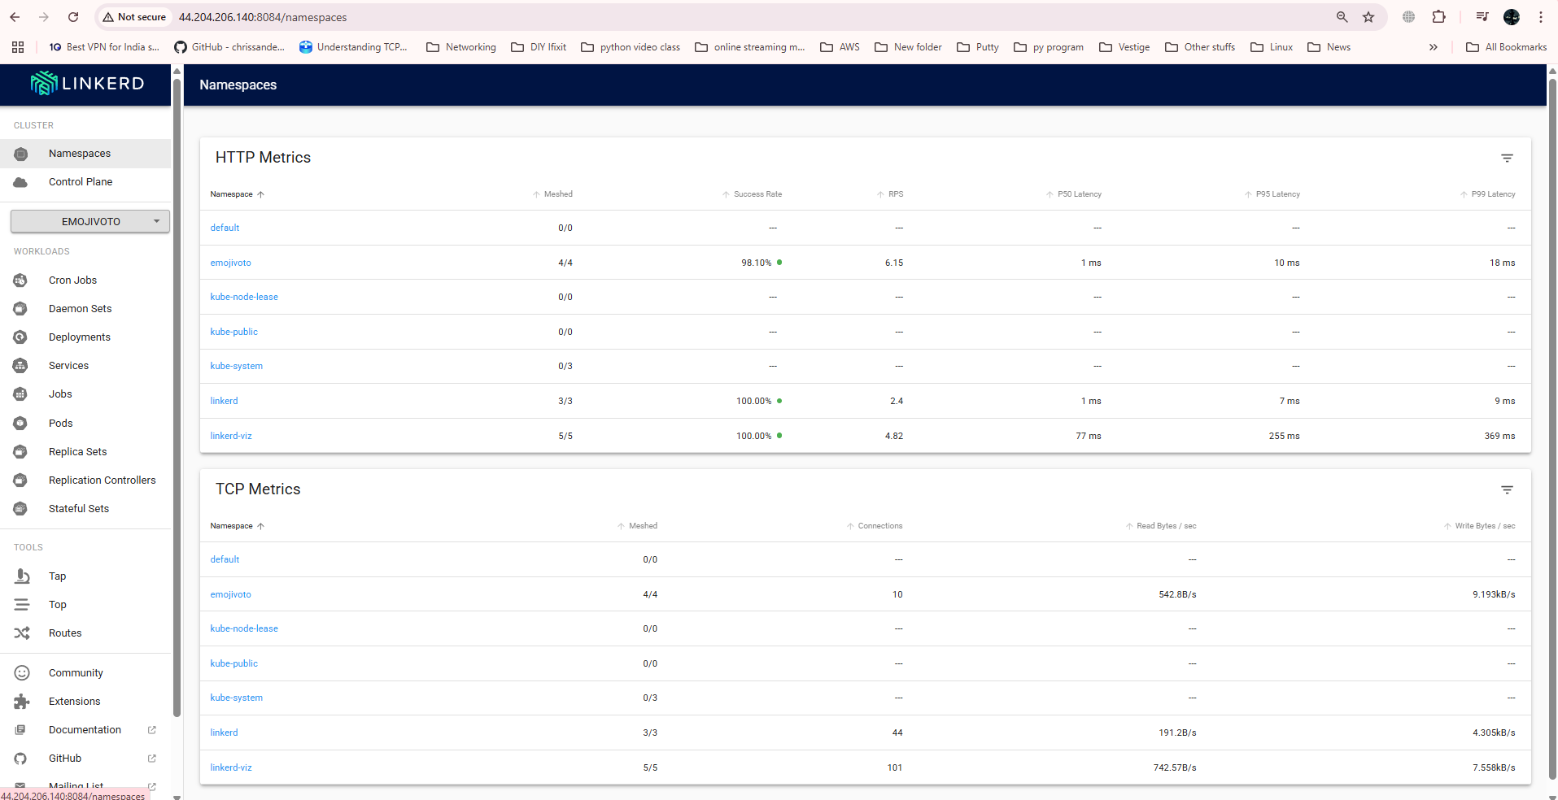

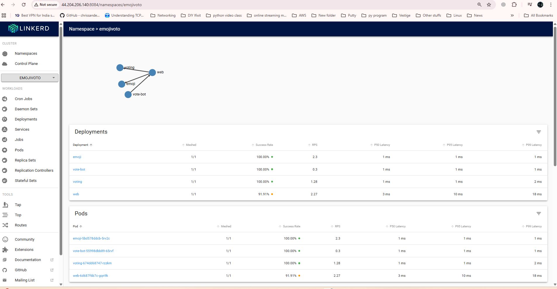

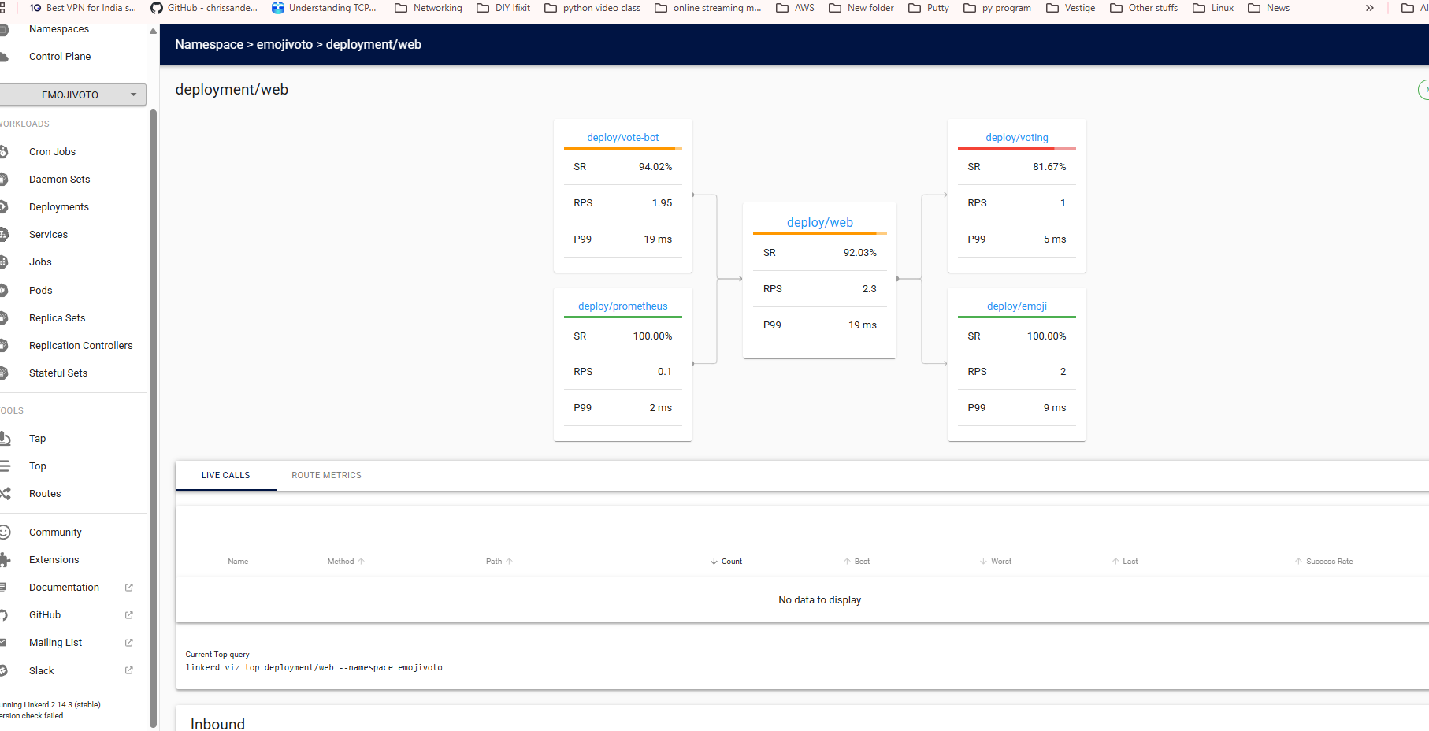

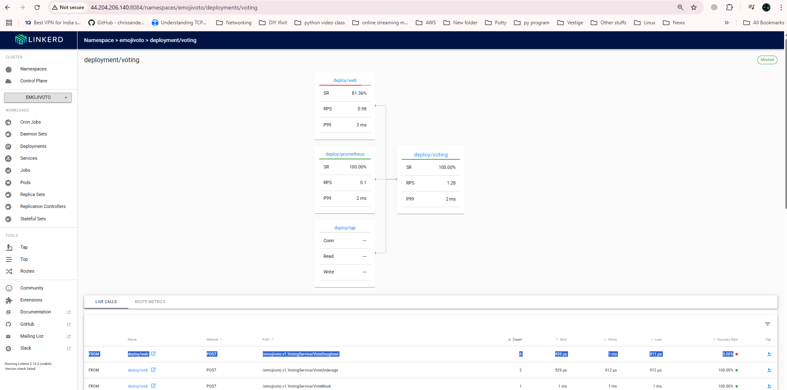

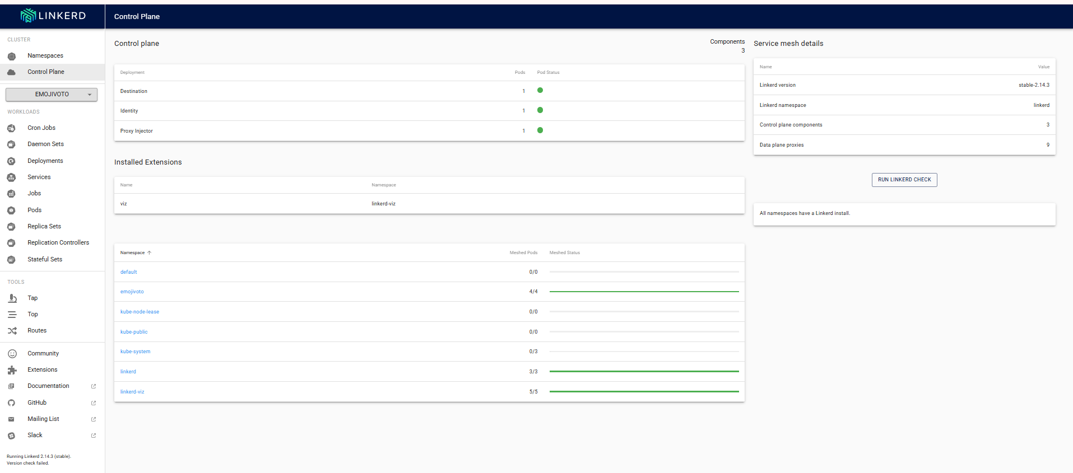

**Conclusion**

This PoC demonstrates the successful deployment of **Linkerd** on **MicroK8s** in an **AWS EC2 Ubuntu instance**. The **Emojivoto application** was deployed with Linkerd proxy injection, and the **Linkerd Dashboard** was made accessible externally for monitoring and visualization.

**Next Steps**

* Implement **TLS security** for exposed ports.
* Integrate **Grafana** for detailed service mesh metrics.
* Deploy a **production-ready** Kubernetes cluster with **HA** settings.